🔵 Question 1:
What is the difference between Flexbox and Grid layout in CSS, and in which scenario would you prefer one over the other?
🟢 Solution:
Flexbox is a one-dimensional layout system, meaning it works best for laying out items in a single row or column. It is ideal when you're aligning items along a single axis (either horizontal or vertical), such as navigation bars, toolbars, or even mobile layouts.
Grid, on the other hand, is a two-dimensional layout system. It allows you to manage both rows and columns simultaneously, which makes it more suitable for more complex layouts like dashboards, image galleries, or full-page designs.
✅ Use Flexbox when your layout is primarily in one direction (like aligning three items horizontally, as shown in the .flex-container section).
✅ Use Grid when you need to place elements in both rows and columns (as in the .grid-container example).

🔵 Question 2:
Analyze the following form element:
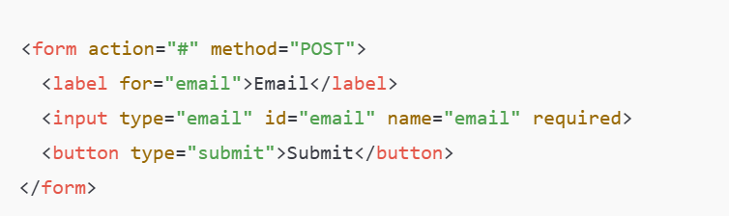
What two types of HTML validation are being applied to the email input field, and how do they work?
🟢 Solution:
- Type Validation (type="email"):
  - The browser checks if the input text matches an email format (e.g., example@domain.com).
  - If not, it will prevent the form from submitting and show an error message.
- Required Field (required):
  - Ensures the input field cannot be left empty.
  - The user must enter a value for the form to be submitted.
Together, these validations ensure that:
- The user enters something, and
- What they enter is in a valid email format.

Chosen Concept: CSS backdrop-filter Property

a. What it is / What it does:
The backdrop-filter CSS property applies graphic effects like blur or brightness to the area behind an element, creating a frosted-glass look. It's often used in modern UI designs to create translucent layers over background content.

b. Example Code (with Explanation):
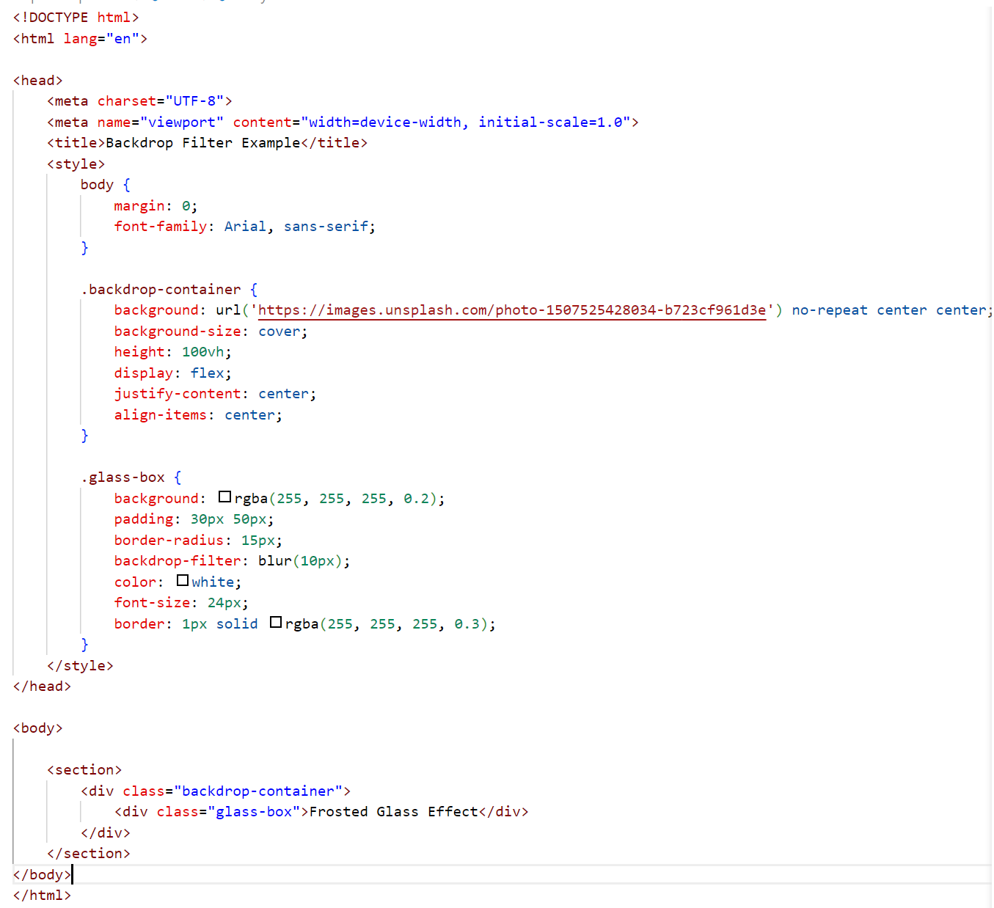
Explanation:
In this example, the .glass-box element is placed over a background image. The backdrop-filter: blur(10px); creates a frosted glass effect by blurring whatever is behind the box. This effect enhances readability while maintaining a sleek design.
s